One-to-Many

🌟 Definition
# Source: AI Source: Provided by: [Data Path: Persons Table -> ID Column: 1, Name_En Column: Motasem Essam] -> From: [ChatGPT] on [6/10/2026]
A One-to-Many (1:N) Relationship exists when one record in Entity A can be related to many records in Entity B, but each record in Entity B can be related to only one record in Entity A.
In other words:
One A → Many B
Many B → One A
This is the most common relationship type in relational databases.

🎯 Purpose
# Source: AI Source: Provided by: [Data Path: Persons Table -> ID Column: 1, Name_En Column: Motasem Essam] -> From: [ChatGPT] on [6/10/2026]
One-to-Many relationships are used when:
- One entity owns multiple related records.
- One parent record has many child records.
- Data naturally forms a hierarchy.

🧠 Simple Example
# Source: AI Source: Provided by: [Data Path: Persons Table -> ID Column: 1, Name_En Column: Motasem Essam] -> From: [ChatGPT] on [6/10/2026]
Customer and Orders
One Customer → Many Orders
One Order → One Customer

Diagram
Customer 1 ───── N Orders

Example Data
Customers Table
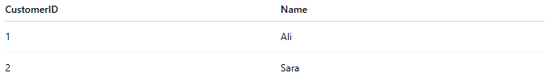
CustomerID | Name
1 | Ali
2 | Sara
Orders Table
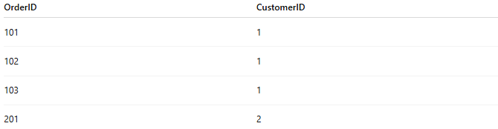
OrderID | CustomerID
101 | 1
102 | 1
103 | 1
201 | 2
Customer Ali has three orders.
Customer Sara has one order.
Each order belongs to only one customer.

📚 Real-World Examples

1. Customer ↔ Orders
# Source: AI Source: Provided by: [Data Path: Persons Table -> ID Column: 1, Name_En Column: Motasem Essam] -> From: [ChatGPT] on [6/10/2026]
Customer 1 ───── N Orders

2. Department ↔ Employees
# Source: AI Source: Provided by: [Data Path: Persons Table -> ID Column: 1, Name_En Column: Motasem Essam] -> From: [ChatGPT] on [6/10/2026]
Department 1 ───── N Employees

3. Teacher ↔ Students
# Source: AI Source: Provided by: [Data Path: Persons Table -> ID Column: 1, Name_En Column: Motasem Essam] -> From: [ChatGPT] on [6/10/2026]
Teacher 1 ───── N Students

4. Category ↔ Products
# Source: AI Source: Provided by: [Data Path: Persons Table -> ID Column: 1, Name_En Column: Motasem Essam] -> From: [ChatGPT] on [6/10/2026]
Category 1 ───── N Products

5. Country ↔ Cities
# Source: AI Source: Provided by: [Data Path: Persons Table -> ID Column: 1, Name_En Column: Motasem Essam] -> From: [ChatGPT] on [6/10/2026]
Country 1 ───── N Cities

📊 ER Diagram Representation
# Source: AI Source: Provided by: [Data Path: Persons Table -> ID Column: 1, Name_En Column: Motasem Essam] -> From: [ChatGPT] on [6/10/2026]
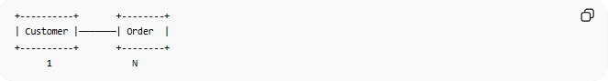
+----------+ +--------+
| Customer |───────| Order |
+----------+ +--------+
1 N
One customer can have many orders.

🗄️ Database Implementation
# Source: AI Source: Provided by: [Data Path: Persons Table -> ID Column: 1, Name_En Column: Motasem Essam] -> From: [ChatGPT] on [6/10/2026]
Customers Table
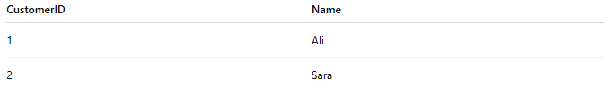
CustomerID | Name
1 | Ali
2 | Sara

Orders Table
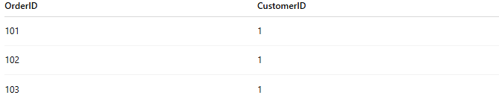
OrderID | CustomerID
101 | 1
102 | 1
103 | 1

SQL Example
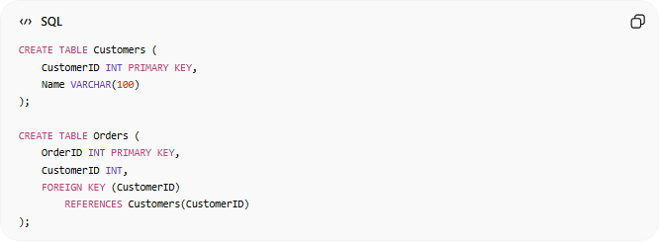
CREATE TABLE Customers (
CustomerID INT PRIMARY KEY,
Name VARCHAR(100)
);
CREATE TABLE Orders (
OrderID INT PRIMARY KEY,
CustomerID INT,
FOREIGN KEY (CustomerID)
REFERENCES Customers(CustomerID)
);
The foreign key creates the relationship.

🔢 Characteristics of a One-to-Many Relationship
# Source: AI Source: Provided by: [Data Path: Persons Table -> ID Column: 1, Name_En Column: Motasem Essam] -> From: [ChatGPT] on [6/10/2026]
- One parent can have many children.
- Each child belongs to one parent.
- Implemented using a foreign key.
- Most common database relationship.

🌍 Department Example
# Source: AI Source: Provided by: [Data Path: Persons Table -> ID Column: 1, Name_En Column: Motasem Essam] -> From: [ChatGPT] on [6/10/2026]
Departments Table
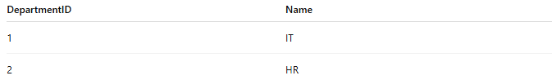
DepartmentID | Name
1 | IT
2 | HR

Employees Table
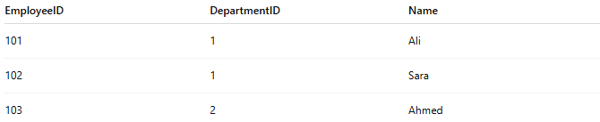
EmployeeID | DepartmentID | Name
101 | 1 | Ali
102 | 1 | Sara
103 | 2 | Ahmed
Relationship:
Department 1 ───── N Employees
The IT department has multiple employees.
Each employee belongs to one department.

⚠️ One-to-Many vs One-to-One
# Source: AI Source: Provided by: [Data Path: Persons Table -> ID Column: 1, Name_En Column: Motasem Essam] -> From: [ChatGPT] on [6/10/2026]
One-to-One
Person 1 ───── 1 Passport
Only one match on each side.

One-to-Many
Customer 1 ───── N Orders
One record can have many related records.

Comparison
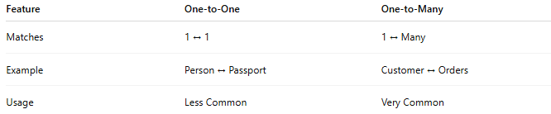
Feature | One-to-One | One-to-Many
Matches | 1 ↔ 1 | 1 ↔ Many
Example | Person ↔ Passport | Customer ↔ Orders
Usage | Less Common | Very Common

⚠️ One-to-Many vs Many-to-Many
# Source: AI Source: Provided by: [Data Path: Persons Table -> ID Column: 1, Name_En Column: Motasem Essam] -> From: [ChatGPT] on [6/10/2026]
One-to-Many
Department 1 ───── N Employees
Each employee belongs to one department.

Many-to-Many
Students M ───── N Courses
Students can take many courses and courses can have many students.

🧠 Simple Analogy
# Source: AI Source: Provided by: [Data Path: Persons Table -> ID Column: 1, Name_En Column: Motasem Essam] -> From: [ChatGPT] on [6/10/2026]
Think of a mother and her children:
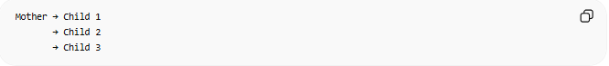
Mother → Child 1
→ Child 2
→ Child 3
One mother can have many children, but each child has one biological mother in this simplified example.
This is a One-to-Many Relationship.

🧭 Summary
# Source: AI Source: Provided by: [Data Path: Persons Table -> ID Column: 1, Name_En Column: Motasem Essam] -> From: [ChatGPT] on [6/10/2026]
A One-to-Many (1:N) Relationship occurs when one record in one entity can be associated with many records in another entity, while each record in the second entity is associated with only one record in the first. Examples include Customer–Orders, Department–Employees, and Category–Products. It is usually implemented using a foreign key in the "many" table.

